Start the Bank account CQRS ES application with excluding Axon server
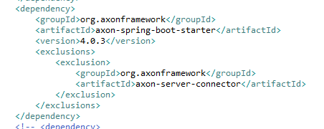

The Axon server url shows that no application is tied to the server
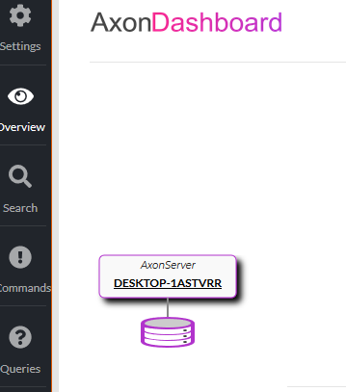

Go to Swagger and create one new account
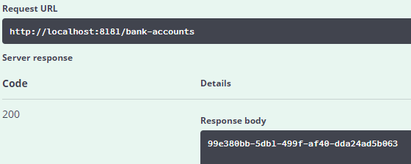

Confirm in H2 console that there is an entry for the newly created account. As expected on entry is there.
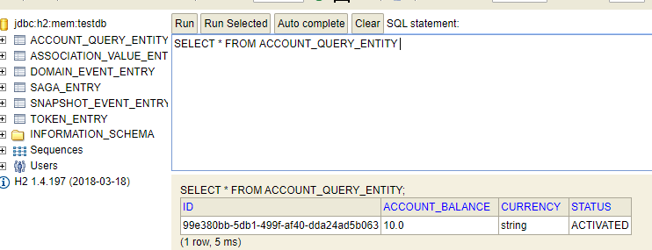

In Swagger query for events generated due to above account create command. As expected 2 events are listed.
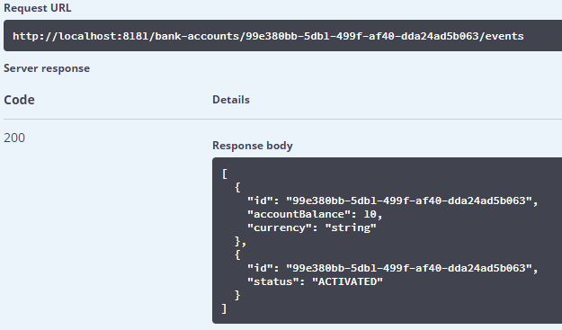

The above event details are not available in H2 console. So, where exactly is the event store? The Axon url shows no application tied to Axon server. H2 console has 2 entries for Domain Entry table but this table is not same as the entries listed in Swagger.
